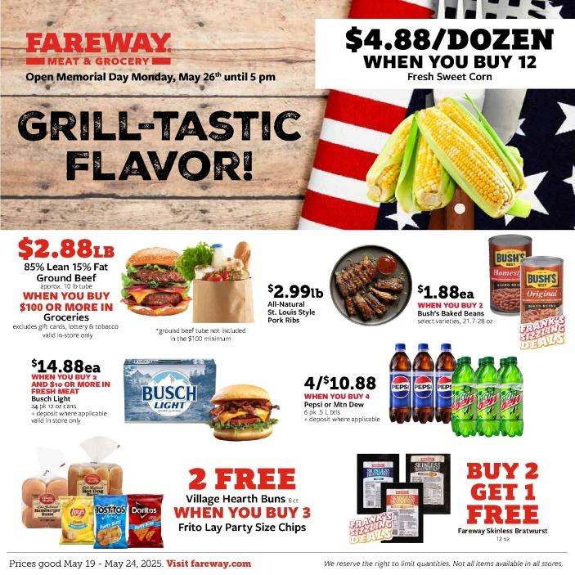
This advertisement offers
A free product for purchase of another product
B half price discount
C wholesale purchase of products
D various products for children
E special holiday picks

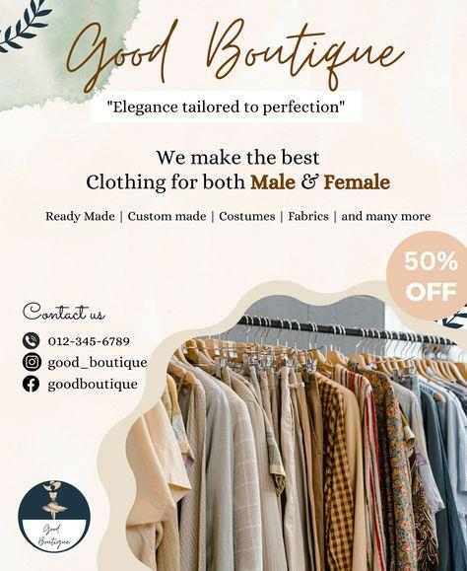
This advertisement offers _______________.
A free product for purchase of another product
B half price discount
C wholesale purchase of products
D various products for children
E special holiday picks


This advertisement offers _______________.
A free product for purchase of another product
B half price discount
C wholesale purchase of products
D various products for children
E special holiday picks



This advertisement offers _______________.
A free product for purchase of another product
B half price discount
C wholesale purchase of products
D various products for children
E special holiday picks


This advertisement offers _____________.
A free product for purchase of another product
B half price discount
C wholesale purchase of products
D various products for children
E special holiday picks

Правильні відповіді:
1 | 2 | 3 | 4 | 5
C | B | A | E | D
Text 1
SHOP ’TIL YOU STOP
by Melinda Beck
For an estimated 6% of Americans with compulsive buying tendencies, this is a tough time of the year as attractive bargains egg people on to spend.
“The whole culture conspires against us in the holiday season,” says April Lane Benson, a Manhattan psychologist. Besides tempting sales and the urge to shop for oneself, she says, “the holidays bring up a lot of unfulfilled longing for some people – and that’s one reason why they shop, as a salve for disappointment.”
While the stereotypical compulsive shopper is traditionally a woman in her 30s, experts say the ease and speed of Internet shopping is luring more men and more young people. Over Black Friday weekend, men outspent women $484 to $317, on average, according to the National Retail Federation. They also spent an average of $200 online – twice as much as the average woman.
In a 2005 survey of 195 U.K. teenagers, who grew up with the Internet, 44% showed signs of compulsive shopping habits, according to research published in the British Journal of Psychology. “The Internet is dangerous for compulsive buyers,” says psychiatrist Elias Aboujaoude. Transactions move so quickly that it is hard to pause to reassess the buying urge, he says.
But when does “retail therapy” cross the line into compulsive shopping? Experts say purchasing turns pathological when people continue to do it even though it causes financial problems, disrupts work, family or social life or involves deceit, such as hiding bills and packages. Feeling out of control is another tip-off.
Compulsive buying disorder is generally considered an impulse-control problem, like gambling or sex addiction. Some sufferers describe feeling their hearts race, cheeks flush and abandoning all sense of caution when they’re stalking favorite items. “Usually, the idea is, ‘I see it, I like it, I want it, I’ll buy it – and damn the consequences,’” says Donald W. Black, a professor of psychiatry at the University of Iowa. But the thrill fades fast and is often followed by remorse, and then more shopping to feel better again.
Many compulsive shoppers also suffer from depression, anxiety or eating disorders, and about half of them are also hoarders. Compulsive shoppers themselves often have a sense of what drives them. Some suffer from low self-esteem and think the perfect dress or accessory will help overcome it.
Arzu Yonak says she shopped out of boredom growing up in rural Ohio. The habit got out of hand when she had an internship in New York – and her father’s credit cards – at age 20. “I remember having five shopping bags in one hand and the phone in the other, saying ‘Mom, I can’t stop!’”
According to the text, why might men now be more involved in compulsive shopping?
A) Stores offer more products for men
B) Men earn more money
C) The Internet makes shopping easier and faster for everyone
D) Women influence men's behavior
What rhetorical purpose does the quote “I see it, I like it, I want it, I’ll buy it – and damn the consequences” serve?
A) It explains how stores advertise products
B) It provides a humorous view of shopping
C) It reflects the impulsive mindset of a compulsive buyer
D) It shows how people write shopping lists
Which of the following is NOT mentioned as a co-existing condition with compulsive shopping?
A) Depression
B) Anxiety
C) Eating disorders
D) Alcohol addiction
What effect does the Internet have on compulsive buying behavior, according to the psychiatrist quoted?
A) It helps buyers get better deals
B) It promotes healthy financial habits
C) It accelerates the process, making it hard to reflect and resist urges
D) It encourages shoppers to pause and think
Правильні відповіді:
1 | 2 | 3 | 4
C | С | D | C

Джерело:
Бек, Мелінда. Shop 'Til You Stop: How to Treat Compulsive Spending [Електронний ресурс] // The Wall Street Journal. – 2011. – 6 грудня. – Режим доступу: https://www.wsj.com/articles/SB10001424052970204903804577080261756886728

Text 2
DROP IN AND SHOP!
1. The new East Cross shopping mall has certainly proved to be very popular. Before it opened last month, people had to travel a long way to avoid paying the high prices that local shops charge. East Cross has brought good quality items with the price range of the average shopper and this is true not only for clothing but for lots of other products too. Check out the offers at the Denby suitcase and handbag shop – they are amazing!
The correct heading:
A Unexpected success
B A disappointment to many
C Value for money
D Not for everyone
E Wonderfully convenient
F A boost to the local small businesses
2. For several months, the developers weren’t sure whether the East Cross shopping mall was going to be built or not. The costs were very high. But I am so glad they decided to go ahead. I just love having all the shops I need in one place, without needing to walk for ages to find what I’m looking for. It’s a short bus ride into the town centre and then all my favourite shops are there under one roof. It’s a great place to meet up with my mates too.
The correct heading:
A Unexpected success
B A disappointment to many
C Value for money
D Not for everyone
E Wonderfully convenient
F A boost to the local small businesses
3. A lot of people were originally unhappy about having a big shopping mall in the town centre but once they saw the plans, I think they realised what an exciting project it was. The idea of having different designer stores right here in East Cross, with cafés and restaurants, and surrounded by lovely gardens that you could walk through was very ambitious, and I’m not sure that even the planners themselves were completely confident. As for myself, I really didn’t think it would be as good as it is! But everything the plans promised has been done and I really enjoy going shopping there. It’s a great experience.
The correct heading:
A Unexpected success
B A disappointment to many
C Value for money
D Not for everyone
E Wonderfully convenient
F A boost to the local small businesses
4. In some towns, when they build a big shopping mall, they do it out of town because of parking problems and maybe competition from high street shops. East Cross has been built right in the town centre and I know some people thought this might be bad for the local shops. Actually, I think it’s done the local shops a big favour. Before East Cross, the town centre wasn’t busy at all. Now everyone comes to the mall and then they go and look at other shops close by. It’s really good for everyone.
The correct heading:
A Unexpected success
B A disappointment to many
C Value for money
D Not for everyone
E Wonderfully convenient
F A boost to the local small businesses
Правильні відповіді:
1 | 2 | 3 | 4
C | E | A | F

Джерело: Get 200! Exam preparation course for Ukraine. Book 1/ Marta Rosinska – Macmillan Education, 2020. – 168 с.

Text 3
Read the text below. Choose from (A–H) the one which best fits each space (1-6). There are two choices you do not need to use.
Shopping Online
Online-shopping and e-commerce are gaining on popularity (1) __________. In 2017, around 2 billion people worldwide purchased goods online (2) __________. Clothing, shoes and accessories, computers and electronics, beauty items, books, movies and music are all among the goods (3) __________.
Yet some people are still reluctant to shop online. One reason is the sense of satisfaction and other people’s appreciation (4) __________. For a typical fashionista getting a must-have jacket delivered straight to the door is just robbing herself of the pleasure of walking down the street and carrying a shopping bag with a designer logo on it.
Another problem while buying online is payment over the internet. Although established online shopping platforms like eBay and Amazon.com have been a great success, many people still refuse to use their credit cards on the Web, especially (5) __________. The increasing rate of cyber-crimes is yet another reason (6) __________.
A – which is popular with younger people
B – that are bought and sold online
C – that retail business has never dreamt of
D – that discourages people from shopping online
E – when getting their money back
F – which is still essential to many people
G – when buying expensive items
H – which accounted for 23.2% of total global retail sales
Правильні відповіді:
1 | 2 | 3 | 4 | 5 | 6
C | H | B | F | G | D

Джерело: Експрес-підготовка до НМТ: Англійська мова / В. Ільченко. – Харків : Асса, 2024. – 128 с.

