Text 1
Read the text below. For questions (1-5) choose the correct answer (A, B, C or D)
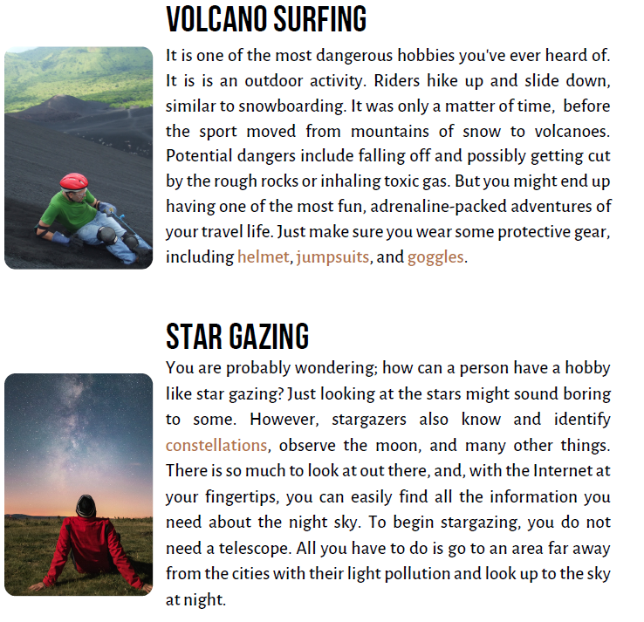

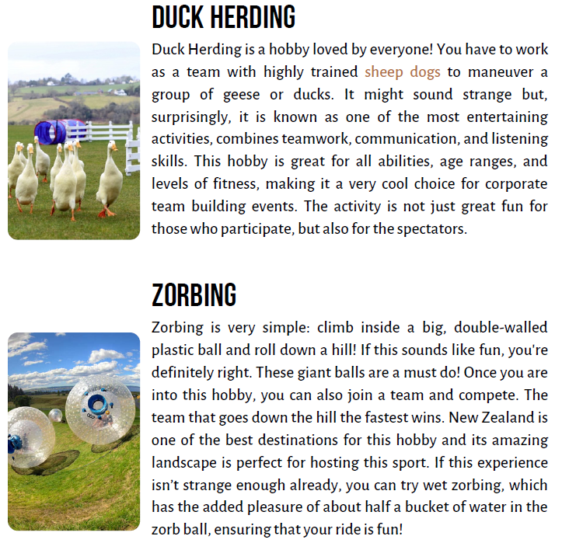

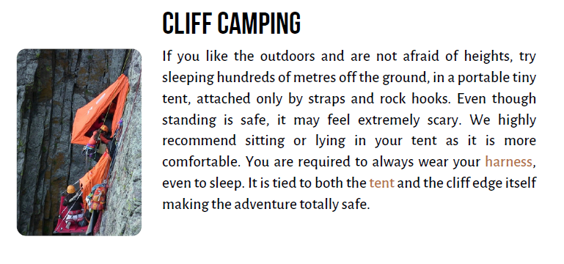

1. What is the main similarity mentioned between volcano surfing and another winter sport (Paragraph 1)?
(A) The equipment used is exactly the same.
(B) Riders move down a slope in a similar way.
(C) Both sports are typically practiced on mountains of ice.
(D) The level of danger involved is minimal in both.
2. According to Paragraph 2, what is one thing stargazers are able to do besides just looking at the stars?
(A) Travel to other planets using telescopes.
(B) Control the movements of the moon.
(C) Recognize and name different constellations.
(D) Create their own stars in the night
3. According to paragraph 3, what makes duck herding a good choice for corporate team building events?
(A) It requires intense physical strength and agility.
(B) It is a very common and widely known activity.
(C) It is entertaining and combines teamwork and communication skills.
(D) It is a solitary activity that allows for individual reflection.
4. What is the basic action involved in the hobby of zorbing (Paragraph 4)?
(A) Climbing a mountain with a large plastic ball.
(B) Rolling down a hill inside a big, double-walled plastic ball.
(C) Competing in teams to build the largest plastic ball.
(D) Filling a plastic ball with water and sliding on flat ground.
5. What safety measure is emphasized in the text regarding cliff camping (Paragraph 5) ?
(A) Campers should avoid wearing a harness to feel more connected to nature.
(B) The tent is only attached to the cliff edge and not the camper.
(C) Campers are required to always wear a harness that is tied to the tent and the cliff.
(D) The activity is recommended for people who have a fear of heights to overcome it.
Правильні відповіді:
1. B) Riders move down a slope in a similar way. (У тексті про volcano surfing сказано: "Riders hike up and slide down, similar to snowboarding." Тобто, волканосерфінг схожий на сноубординг способом пересування — спуск вниз зі схилу.
2. C) Recognize and name different constellations. (У тексті “Star gazing” йдеться: "stargazers also know and identify constellations..." Отже, одна з активностей – це розпізнавання сузір’їв).
3. C) It is entertaining and combines teamwork and communication skills. (У тексті “Duck herding” читаємо: "...combines teamwork, communication, and listening skills..." "...making it a very cool choice for corporate team building events." Отже, це активність, що потребує командної роботи і спілкування.
4. B) Rolling down a hill inside a big, double-walled plastic ball. (У тексті чітко сказано: "climb inside a big, double-walled plastic ball and roll down a hill!" Це – основна дія в зорбінгу.
5. C) Campers are required to always wear a harness that is tied to the tent and the cliff. (У розділі cliff camping зазначено:"You are required to always wear your harness... It is tied to both the tent and the cliff edge..." Це – головний захід безпеки при кемпінгу на скелі).
Text 2
Complete the text. There are two extra sentences you don’t need to use
Extreme ironing is a hobby where people iron clothes in unusual outdoor locations, sometimes combining it with (1) ______. It started in the 1980s with Tony Hillman. While not a traditional sport, some teams treat it as one due to the (2) ______ of combining ironing with activities like climbing or canoeing.
Extreme ironing even had a (3) ______ in Germany in 2002. However, its popularity is (4) ______ because it usually requires existing skills in an extreme sport. Skilled canoeists, for example, might prefer canoeing over ironing while canoeing. This makes it a niche activity, often done for extra excitement or online attention.
To do extreme ironing, the needed equipment depends on the location. For a mountain, climbing gear is essential. For skiing, ski equipment is required. The ironing-specific items include a portable ironing board, a cordless iron, water for the iron, and a (5) ______.
Extreme ironing is suitable for fit and healthy individuals already skilled in an extreme sport. Trying it without mastering the base sport first can be very dangerous. It’s more of an add-on for experienced athletes than (6) ______. You need to be able to ski before you try ironing while skiing!
a) limited due to required skills
b) easy to do without any experience
c) physical challenge
d) world championship event
e) combining it with extreme sports
f) the safest way to iron indoors
g) an activity for complete beginners
h) backpack for carrying clothes
Правильні відповіді:
1. e) combining it with extreme sports — у тексті говориться про екстремальні місця, і логічно, що мова йде про поєднання з екстремальними видами спорту (наприклад, скелелазінням чи каное). Саме це згадується далі у тексті.
2. c) physical challenge - комбінація прасування з лазінням чи веслуванням — це фізичне випробування. Саме тому команди сприймають це як спорт.
3. d) world championship event — мова йде про велику подію. Варіант “world championship event” (чемпіонат світу) ідеально підходить за змістом.
4. a) limited due to required skills — популярність обмежена, бо потрібні навички у складних видах спорту — саме це і сказано у реченні.
5. h) backpack for carrying clothes — у цьому переліку вказано обладнання для прасування, тому “рюкзак для перенесення одягу” логічно доповнює список.
6. g) an activity for complete beginners — ідея — це не заняття для новачків, а щось додаткове для досвідчених спортсменів.
Зайві варіанти:
b) easy to do without any experience — суперечить змісту тексту, де говориться про складність.
f) the safest way to iron indoors — не стосується outdoor (зовнішнього) характеру хобі.
Text 3

Read the text and define the sentences 1-5 as True or False

How about doing some ironing in mid-air in the middle of a skydive? If you think you know what a bizarre hobby looks like, you haven’t come across these people before. Taking up an interest in your spare time and sticking to it takes passion and dedication, but to read about some of the following pursuits it would seem that insanity is also a vital ingredient to maintaining a hobby. What makes someone suddenly decide that they want to start collecting their own belly fluff and keep it in a jar?
PAINTING THE BIGGEST EVER BALL OF PAINT (USA): Some record-breakers have tried making the world’s largest ball out of rubber bands, but this concept is so last decade. How about a ball made up of endless layers of paint? Now you’re talking! What started out as a regular size baseball has now become a gigantic paint ball weighing a whopping 3,500 lbs (1587 kg) after a man began covering his baseball with a coat of paint every day since 1977!
Michael Carmichael from Indiana asked his son to paint the first ever coat of paint back in the late 70s. Since then, he has applied a new layer of paint ever since with only one rule – that each layer has to be a different color from the last. The mammoth ball of paint has attracted tourists from all over the world to Michael's home and some are even allowed to add the next coat to the ball. He apparently has plans to pass the ball on to his grandchildren as a family heirloom.
MOOING (USA): This is about as minimal as a hobby can get. The activity of mooing pretty much just involves...that’s right, mooing. However, professional mooers (or is that mooists?) didn’t think it was enough just to imitate a cow with their voice, so they built an entire community around it and that, of course, involves dressing up as cows and holding state fairs and competitions around the country to celebrate the wonders of mooing together. How utterly ridiculous.
The hobby of mooing originated in the dairy state of Wisconsin where the official mooing competition known as "Moo-la-palooza" is held in order to try and find the best cow impersonator ever. The most recent winner of the Moo-la-palooza grand prize was 10-year-old Austin Siok who delivered a "Moo" so fantastic, he won $1000, a golden cow bell and a year’s supply of sub sandwiches.
POLISHING DIRT (JAPAN): They say you can’t polish a turd, well some people of the world like to polish something pretty similar – bits of dirt and mud. The Japanese art of polishing up mud balls is known locally as Hikaru Dorodango and it involves rolling bits of mud into a ball and coating it in fine grains of soil to create a smoother surface. After repeating this process several times, the moisture is drawn out of the mud balls, allowing the person to polish them until they’re left with a shiny ornamental ball (and very smelly hands).
How and why this ever became a thing is unknown, but the hobby of refining and polishing balls of dirt is said to have been a traditional game among children. Looking at the finished product, you’d think they were expensive ornaments from Pottery Barn, but we know the truth and it's pretty gross.
- Michael Carmichael has been adding layers of paint to a rubber ball for over four decades.
- Visitors from different countries can only observe the paint ball but are not allowed to interact with it.
- The Moo-la-palooza contest awards include both cash prizes and food.
- The narrator suggests that passion and dedication alone are not enough to pursue some of these hobbies.
- The hobby of polishing mud balls is considered modern and originated in urban Japan.

Правильні відповіді:
1. False (У тексті сказано: “What started out as a regular size baseball has now become a gigantic paint ball…” І далі: “…covering his baseball with a coat of paint every day since 1977.” Отже, це не гумовий м'яч, а бейсбольний м'яч, тому твердження неправдиве.
2. False (У тексті сказано: “…some are even allowed to add the next coat to the ball.” Це означає, що туристи можуть взаємодіяти — додавати фарбу. Отже, твердження неправдиве).
3. True (“...he won $1000, a golden cow bell and a year’s supply of sub sandwiches.” Тут є і грошова винагорода, і їжа, тому твердження правдиве).
4. True (“...but to read about some of the following pursuits it would seem that insanity is also a vital ingredient to maintaining a hobby.” Отже, однієї пристрасті недостатньо — ще потрібна, за словами автора, трохи "божевільності", тому твердження правдиве).
5. False (“...the hobby...is said to have been a traditional game among children.” Це традиційне, а не сучасне, і немає згадки про міста, тому твердження неправдиве).
Список використаних джерел
- https://files.happy-hearts.com.ua/english/A2%20B1%20Hobbies%20that%20would%20surely%20surprise%20you%20TV.pdf
- https://hobyideas.wordpress.com/2018/07/26/extreme-ironing-as-a-hobby/
- https://en.islcollective.com/english-esl-worksheets/general-topic/hobbies/weird-hobbies/108104

