Тренувальний тест № 3
Частина “ЧИТАННЯ”
Reading
Task 1. Read the texts below. Match choices (A–H) to (1–5). There are three choices you do not need to use.

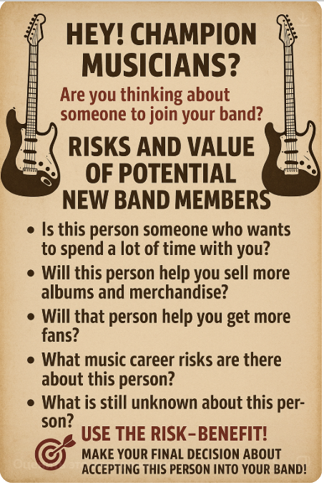1. | 2.
3. | 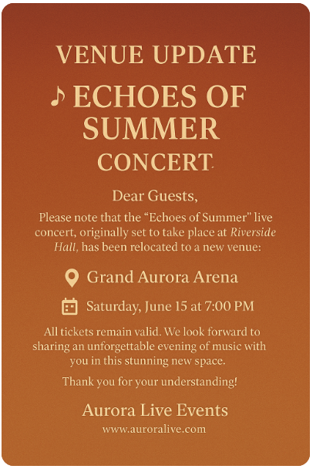4.
5. | This advertisement is for people who would like to ______________.  A. look for musicians to join the band  B. take part in a celebration  C. visit a musical show  D. go to the guitar concert  E. improve their musical playing methods  F. have a chance to grab a real bargain  G know about the new event location  H. take part in a classical music recital

Task 2. Read the texts. For questions (6-10) choose the correct answer A, B, C or D

Non-Musical Benefits of Music in Early Education

Music education is more than just learning how to play an instrument or sing a song. It has many benefits that can positively impact a child's development in the classroom and beyond!

Research has shown that music education can help improve cognitive skills such as memory, attention, and problem-solving, as well as emotional skills such as empathy and self-expression. It can also foster creativity, collaboration, and cultural awareness.

At a time when many schools are cutting music programs due to budget constraints, it's important to recognize the value of music education and advocate for its inclusion in the curriculum. Let's give our children the gift of music education and help them unlock their full potential! Music education #classroom benefits #cognitive skills #emotional skills #creativity #collaboration #cultural awareness #budget cuts #advocacy #unlock potential. At Show Me Mozart, we believe that every child deserves to express themselves through music. Be the hero that changes a child's life through music. Schedule a call today to see how easy it is to bring music to your classroom, visit us at: Show Me Mozart School.

- The headline shows that:
A. children achieve the benefits in other spheres of their lives learning music
B. early education is very important
C. modern primary schools teach without music programs
D. it doesn't matter whether there are music lessons at school or not
- The research has shown that music education can help improve:
A. emotional and physical skills
B. collaboration, and cultural awareness only
C. cognitive, emotional skills and creativity
D. soft and hard skills
- Why are schools cutting music programs?
A. due to the lack of music teachers
B. because music is not the main subject
C. schools advocate for its inclusion in the curriculum
D. due to the lack of money
- The author believes that:
A. not every child deserves to express themselves through music
B. every child deserves to express themselves without music
C. every child may express themselves through music
D. every child deserves to express themselves through collaboration
- Who is the author of the text?
A. The teacher of Show Me Mozart School
B. Experts of music education
C. Famous musicians
D. Children of Show Me Mozart School

Task 3. Read the texts below. Match choices (A – H) to (11 – 16). There are two choices you do not need to use.
Six Greatest Music Festivals
11. Glastonbury (the UK)
Glastonbury Festival, often referred to simply as "Glasto," is one of the most famous music festivals in the world. It was founded in 1970 by Michael Eavis on his dairy farm in Pilton, Somerset. The festival has grown exponentially since its inception, transforming from a small event with a few hundred attendees into a massive five-day spectacle attracting over 200,000 people. Known for its diverse lineup that spans various genres, Glastonbury has become a cultural icon and a staple in the music festival scene.
12. Coachella (the USA)
Coachella Valley Music and Arts Festival, commonly known as Coachella, is a premier music and arts festival held annually in Indio, California. It was founded in 1999 by Paul Tollett and Rick Van Santen and has since evolved into a two-weekend event that attracts some of the biggest names in music and a diverse crowd of attendees. The festival is not just about music; it also features a significant focus on art. Large-scale art installations and sculptures are a staple of the event, with new pieces debuting each year to captivate and inspire attendees. These installations create a unique visual experience that complements the musical performances.
13. Tomorrowland (Belgium)
Tomorrowland, one of the world's most iconic electronic dance music (EDM) festivals, began in 2005 in Boom, Belgium. Created by the brothers Manu and Michiel Beers, Tomorrowland has grown exponentially from its modest beginnings to become a global phenomenon, attracting over 400,000 attendees from around the world. The festival is held annually over two weekends in July and is celebrated for its elaborate and fantastical stage designs, high production values, and a lineup that features the biggest names in electronic music.
14. Rock in Rio (Brazil)
Rock in Rio is a legendary music festival that originated in Rio de Janeiro, Brazil, in 1985. Founded by entrepreneur Roberto Medina, the festival was initially created to promote culture, music, and tourism in Brazil. Since its inception, Rock in Rio has expanded globally, with editions held in Lisbon, Madrid, and Las Vegas, showcasing a diverse range of musical genres beyond rock, including pop, electronic, and Brazilian music.
15. Fuji Rock (Japan)
Fuji Rock Festival is Japan's largest outdoor music event, held annually since 1997 at the Naeba Ski Resort in Niigata Prefecture. Initially conceived as a response to the cancellation of another music festival, Fuji Rock has grown into a three-day extravaganza attracting tens of thousands of attendees each year. The festival is renowned for its scenic mountainous backdrop and commitment to environmental sustainability.
16. Sziget (Hungary)
Sziget Festival is one of Europe’s largest and most popular music festivals, held every August on Óbuda Island in Budapest, Hungary. It was founded in 1993 by a group of Hungarian artists and music lovers as a low-budget student event. Since then, Sziget has grown into a week-long international festival, attracting hundreds of thousands of people from around the world. Known as the “Island of Freedom,” it offers a wide range of music genres including rock, pop, indie, and electronic, as well as theater, dance, and art performances. Its multicultural atmosphere and riverside location make it a unique and unforgettable experience.
Which category does this festival belong to?
A The festival that offers workshops on art techniques for attendees.
B. A long-running event that hosts a mix of music and arts
C. A gathering focused on electronic music and immersive visuals
D. A festival set in a picturesque outdoor location with an eco-friendly ethos
E. An event originally designed to boost local culture and attract visitors
F. A long-established celebration of rock music
G. The festival which was originally set up on a private agricultural property
H. A major European festival that began as a modest youth-led cultural initiative

Task 4. Read the text below. Choose from (A-H) the one which best fits each space (17-22). There are two choices you do not need to use.
Cher: A Music and Film Icon
Born in 1946 in El Centro, California, Cher began her career in the early 1960s when she (17) ____________ Sonny Bono. Together, they released several songs, including Let the Good Times Roll and Love is Strange. Soon after, Cher started her solo career with the album All I Really Want to Do, which (18) ___________
Her music career, (19) ___________and with Sonny to whom she was married from 1964 to 1975. Their biggest hit I Got You Babe became a number-one song in 1965. In the following years, Cher released solo albums like The Sonny Side of Chér and Chér, and also appeared on television. Over more than five decades, Cher has (20) ___________, 3 live albums, 11 compilation albums, and 4 soundtracks.
Cher is also known for her work in film. She (21) ________ such as Burlesque (2010) and Mamma Mia! Here We Go Again (2018). There are even rumours she may appear in a third Mamma Mia! film. In 1998, Cher and Sonny received a star on the Hollywood Walk of Fame, shortly after his passing. Over the years, Cher has (22) ______________, including Grammys, Billboard Music Awards, Golden Globes, and even an Academy Award.
- Moved to Los Angeles and met young musician
- Acted and sang in popular movies
- won a lot of major awards
- continued to grow both as a solo artist
- entered the Top 20 on the Billboard 200 chart
- played the role of a music teacher in a Broadway musical
- started a charity foundation for young filmmakers in 2002
- released 27 studio albums

Частина "ВИКОРИСТАННЯ МОВИ"
Use of English
Task 5. Read the text. For questions (23-27) choose the correct answer A, B, C, or D.

Post-Eurovision
In November 1974, ABBA embarked on their first European tour, playing (23) ______ in Denmark, West Germany and Austria. It was not as successful as the band had hoped, since most of the (24) ______ did not sell out. Due to a lack of demand, they were even forced to cancel a few shows, including a sole concert scheduled in Switzerland. The second leg of the tour, which took them through Scandinavia in January 1975, was very different. They played to full houses everywhere and finally got the reception they had aimed for. Live (25) _________ continued in the middle of 1975 when ABBA embarked on a fourteen open-air date tour of Sweden and Finland. Their Stockholm show at the Gröna Lund amusement park had an estimated (26) _________ of 19,200. Björn Ulvaeus later said, "If you look at the (27) __________we released straight after Waterloo, we were trying to be more like The Sweet, a semi-glam rock group, which was stupid because we were always a pop group."
 | A | B | C | D
23 | notes | dates | beats | lyrics
24 | headphones | bands | venues | playlists
25 | rehearsals | tracks | performances | covers
26 | rhythm | playlist | setlist | audience
27 | albums | singles | songs | tracks

Task 6. Read the text. For questions (28-32) choose the correct answer A, B, C, or D.
Last weekend, I went to see my favorite band (28) ________ at a small venue in the city. By the time I arrived, they (29) ___________playing by air, and the atmosphere was electric. The band had been rehearsing (30) ______weeks, and their performance was even (31) ________ than I had expected. (32) ___________ the venue being small, they had managed to play to full houses every night of their tour.
 | A | B | C | D
28 | to perform | perform | performed | performs
29 | have already started | started | had already been starting | had already started
30 | for | since | on | in
31 | better | more worse | more better | worse
32 | However | Despite | Nevertheless | For

Keys:
Task 1:1. A 2. C 3. E 4. G 5. F
Task 2: 6.A 7. C 8. D 9. C 10. A
Task 3: 11. G 12. B 13. C 14. E 15. D 16. H
Task 4: 17. A 18. E 19. D 20. H 21. B 22. C
Task 5: 23. B 24. D 25. C 26. D 27. A
Task 6: 28. B 29. D 30. A 31. A 32. B

Пояснення до тренувального тесту № 3
Task 1:
- A – look for musicians to join the band
The ad is about helping musicians decide whether to accept a new person into their band. It gives questions to evaluate the risks and benefits of adding a new member.
- C – visit a musical show
This advertisement lists live music events with artists such as Ross Cooper, Casey Heckman, and Scott Sean White. It includes dates, times, ticket prices, and venue details, which means it’s inviting people to attend or visit musical performances.
- E – improve their musical skills
The ad offers free guitar lessons to help beginners learn and improve their strumming techniques and playing skills.
- G. know about the new event location
The poster informs attendees that the “Echoes of Summer” concert has been moved from Riverside Hall to Grand Aurora Arena. It is clearly aimed at people who already planned to attend and need to know the updated venue.
- F. have a chance to grab a real bargain
The poster advertises a Fender Player Stratocaster guitar for sale, highlights features like "modern sound" and "timeless style," and says “price negotiable.” This clearly targets people looking to buy a guitar, especially at a potentially reduced price, making it a bargain.
Task 2:
- The headline shows that:
A: children achieve the benefits in other spheres of their lives learning music.
The text highlights the non-musical benefits of music, suggesting that music education impacts children’s development in various areas like cognitive, emotional, creativity, and collaboration skills.
- The research has shown that music education can help improve:
C: cognitive, emotional skills and creativity.
The text specifically mentions that music education improves cognitive skills (memory, attention, problem-solving), emotional skills (empathy, self-expression), and fosters creativity.
- Why are schools cutting music programs?
D: due to the lack of money.
The text states that many schools are cutting music programs "due to budget constraints," indicating the lack of funding as the reason for these cuts.
- The author believes that:
C: every child may express themselves through music.
The author states that they believe every child deserves to express themselves through music, showing a strong belief in the value of music education for all children.
- Who is the author of the text?
A: The teacher of Show Me Mozart School.
The author of the text is involved in music education at Show Me Mozart, which is directly stated in the text. The reference to the school and its educational program suggests the author’s role there.
Task 3:
- Glastonbury (UK) – G: The festival which was originally set up on a private agricultural property.
Glastonbury was founded by Michael Eavis on his dairy farm, which makes it fit into this category.
- Coachella (USA) – B: A long-running event that hosts a mix of music and arts.
Coachella is known not only for its music but also for its significant focus on art, with large-scale installations and sculptures.
- Tomorrowland (Belgium) – C: A gathering focused on electronic music and immersive visuals.
Tomorrowland is an iconic electronic dance music (EDM) festival, known for its elaborate stage designs and high production values.
- Rock in Rio (Brazil) – E: An event originally designed to boost local culture and attract visitors.
Rock in Rio was created to promote culture, music, and tourism in Brazil, aligning with this category.
- Fuji Rock (Japan) – D: A festival set in a picturesque outdoor location with an eco-friendly ethos.
Fuji Rock is known for its scenic mountainous backdrop and commitment to environmental sustainability.
- Sziget (Hungary) – H: A major European festival that began as a modest youth-led cultural initiative
The text says it was founded by Hungarian artists and music lovers as a low-budget student event, which suggests a youth-led and modest beginning, later growing into a major European festival.
Task 4:
- A. moved to Los Angeles and met young musician
The sentence refers to the beginning of Cher’s career, specifically when she met Sonny Bono. Option A directly states this with the phrase "met young musician", matching the context.
- E. entered the Top 20 on the Billboard 200 chart
The sentence mentions Cher's first solo album, and we expect a result or success. Option E fits logically as it describes the album's chart success, which is common in describing musical careers.
- D. continued to grow both as a solo artist
The sentence talks about her music career and her work with Sonny. Option D fits grammatically and contextually, showing how her career progressed in both directions—solo and duo.
- H. released 27 studio albums
The phrase emphasizes her prolific career, releasing numerous studio albums.
- B. acted and sang in popular movies
The sentence mentions Burlesque and Mamma Mia!, both of which are musical films where Cher acted and sang. Option B clearly summarizes her dual role in these movies.
- C. won a lot of major awards
The sentence lists many awards (Grammys, Golden Globes, etc.), so the logical conclusion is that she won them, which matches Option C perfectly.

Task 5
- B – dates
The correct answer is dates because the phrase “playing dates in Denmark, West Germany and Austria” refers to scheduled performances or concerts. In the music industry, a date often means a specific time and place for a performance.
- A – notes refers to musical notation, which doesn't make sense in this context.
- C – beats are rhythmic units of music, not relevant to the idea of scheduled concerts.
- D – lyrics are the words of songs and unrelated to touring or performance scheduling.
- C – venues
The correct answer is venues because the sentence says “most of the venues did not sell out.” Venue refers to the place where an event (like a concert) is held.
- A – headphones are personal audio devices, irrelevant here.
- B – bands are musical groups, not the locations of the events.
- D – playlists are song collections, not physical locations for concerts.
- C – performances
The correct answer is performances because it refers to live events where music is played for an audience. The sentence talks about ABBA continuing to perform live, so performances fits naturally.
- A – rehearsals are private practice sessions, not public concerts.
- B – tracks are individual recordings, not live events.
- D – covers are versions of songs by other artists, not related to touring activities.
- D – audience
The correct answer is audience because “an estimated audience of 19,200” describes the number of people who attended the concert. Audience is the group of people watching a live performance.
- A – rhythm refers to musical timing, not people.
- B – playlist is a selection of songs, not a crowd.
- C – setlist is a list of songs to be performed, not the listeners.
- B – singles
The correct answer is singles because ABBA released individual songs after their big hit “Waterloo.” A single is a song released separately to promote an artist or upcoming album.
- A – albums are full-length collections of songs, and while relevant, the context here is about immediate releases following a hit.
- C – songs is too general and doesn’t fit the specific idea of marketing or strategic releases.
- D – tracks is a broader term and not as precise as singles in this context.
Task 6:
- B - perform
The verb "perform" should be in the base form after the phrase "I went to see," indicating the planned action at the time. The phrase is in the past tense, so the base form is used to express the event the speaker was going to see.
- D - had already started
This is the correct past perfect tense, which is used to show that the action (starting to play by air) was completed before the speaker arrived. The past perfect is appropriate here as it describes an action that had already begun in the past before another past event.
- A - for
"For" is used to indicate a period of time, and here it correctly refers to the length of time (weeks) the band had been rehearsing. "Since" would refer to a specific point in time, which doesn't fit the context.
- A - better
"Better" is the correct comparative form of "good," and it is used to compare the band's performance with the speaker's expectations. "more worse" and "more better" are grammatically incorrect.
- B - despite
"Despite" is the correct word here because it introduces a contrast between the small venue and the band's success in playing to full houses. "However" does not work in this context as it is more appropriate for joining two contrasting statements.

