Тренувальний тест № 4
Частина «ЧИТАННЯ»
Reading
Task 1. Read the texts below. Match choices (A-H) to (1-5). There are three choices
you do not need to use.

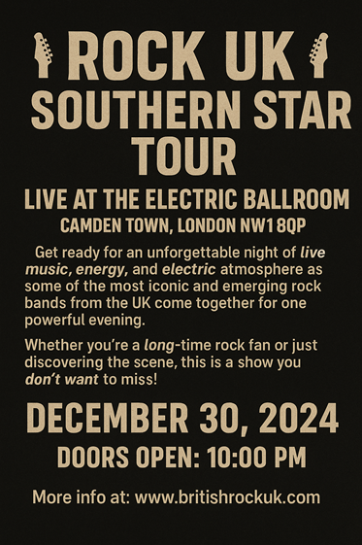1. | 2.
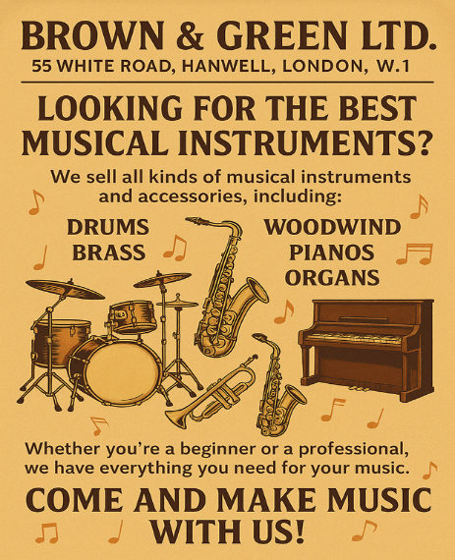3. | 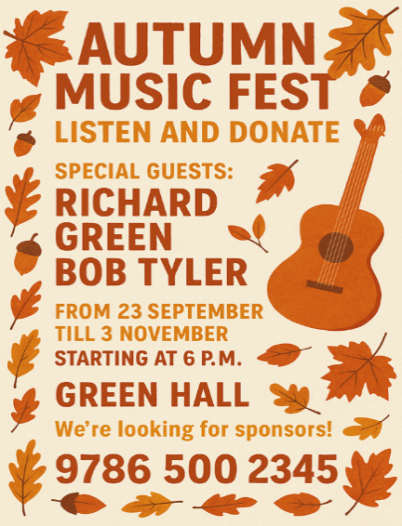4.
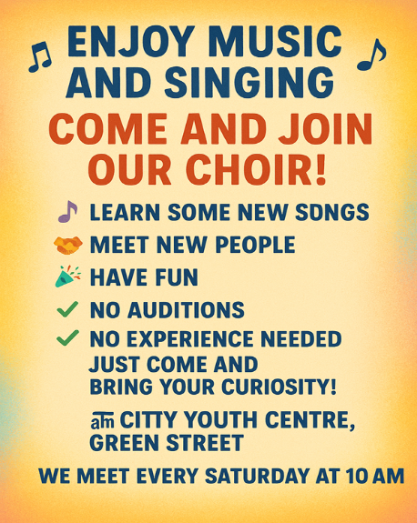5. | Which advertisement is for people who would like to_____?  A go on a guided tour  B buy a musical instrument  C go to the cinema  D participate in a charity event  E adopt a pet  F go to the concert  J visit a firework display  H start a new hobby

Task 2. Read the text below. For questions (6-10) choose the correct answer (A, B, C or D).
The history of Glastonbury Festival
The first festival at Worthy Farm was called the Pilton Pop, Folk and Blues Festival and took place in late Summer 1970, opening the day after Jimi Hendrix died. It was attended by 1,500 people. Admission was £1, which included free camping and free milk. Audiences enjoyed performances by Marc Bolan's Tyrannosaurus Rex who played in place of the Kinks who were due to headline.
Michael and Jean Eavis, festival co-founders, had been inspired by the Bath Festival of Blues and Progressive Music in Shepton Mallet, Somerset and by the success of the Isle of Wight Festival and Woodstock in the US the previous year, and decided to host a festival at the Eavis family dairy farm.
By 1971 the festival had been renamed The Glastonbury Fayre and the date was changed to coincide with summer solstice, an anniversary celebrated at nearby Stonehenge, home to the world-famous Neolithic monument. Key organisers now included Andrew Kerr and Arabella Churchill. The team drew up a manifesto which set out the environmental and spiritual focuses at the heart of the Festival's ethos.
The Festival founders saw the event as a place for the "expression of free-thinking people". In the same year, the first Pyramid Stage, a replica of the Great Pyramid of Giza in Egypt, was designed and built by Bill Harkin and crew out of scaffolding, expanded metal and plastic sheeting.
Broadcasts and popularity
The Festival took another leap in its development in the early 1990s as it attracted the new wave of Britpop bands and became an important destination for the emerging dance and rave culture. In 1994 Oasis, Pulp, Blur and Radiohead all made their festival debuts as Glastonbury embraced the rising stars of the burgeoning British music industry. In the same year a new Pyramid Stage was hastily erected after the original stage was lost in an accidental fire just days before the Festival was due to start. This seminal festival year also saw Glastonbury's first television broadcast by Channel 4 – a significant moment in establishing the Festival's ongoing success and popularity (continued by the BBC from 1997). In 1998, TV audiences could join festival-goers in watching Tony Bennett take the stage on the new Sunday afternoon 'legends slot', reserved for established, well-loved artists, often from a different musical world to the more traditional Glastonbury fare.

6. What did £1 admission to the first festival include?
A. Only entrance to the festival.
B. Entrance and free drink
C. Nothing
D. Free camping and free milk
7. What inspired Michael and Jean Eavis, festival co-founders, to hold the festival?
A. Several popular music events
B. A trip to Bath
C. The Great Pyramid of Giza in Egypt
D. The Glastonbury Fayre
8. What was the main focus of the festival according to the manifesto in 1971?
A. Music and entertainment
B Environmental and spiritual values
C. Harmony with nature
D. Modern music styles
9. What happened to the original stage in 1994?
A. It was stolen
B. It burnt out
C. Nothing
D. It was not ready
10. When was the festival first broadcast on television?
A. In 1990
B. In 1994
C. In 1997
D. In 1998

Task 3. Read the texts below. Match choices (A – H) to (11 – 16). There are two choices you do not need to use.
Popular music styles
11. Blues
The blues is a style of music created by African Americans at the end of the 19th Century. It developed out of folk music, spiritual songs and work songs. Following the American Civil War, the blues spread throughout America as African American people were now free to travel. The blues became popular in cities such as Chicago and Detroit.
12. Jazz
Jazz emerged as a new style of music in the early twentieth century in the African American communities of New Orleans. Jazz has its origins in blues and ragtime. Jazz features lots of improvisation, which requires musicians to: creatively explore and experiment with sound,
express themselves, listen carefully to themselves and the people they make music with,
and respond to the improvisation of people they are playing with. All of this is done spontaneously, with musicians having to react in real time to what is going on around them.
13. Gospel
Gospel music has its origins in the hymns, spirituals and sacred songs found in Afro-American culture in the 18th and 19th Century. Gospel songs were originally sung by African slaves. Lyrics related to escaping to freedom, with a religious element often in praise or giving thanks to God.
14. Rock
Today’s rock music developed from rock 'n' roll. It can come in many different styles but usually features: electric guitar, bass guitar, drum kit. Most rock bands also feature a singer. The songs written by rock bands usually have powerful lyrics and the music underpinned by a heavy beat.
15. Reggae
Reggae is a unique form of rock music which originated in Jamaica. It has its roots in a number of other musical styles. You can hear the influence of traditional Jamaican music as well as American rhythm ‘n’ blues, which would have been easily picked up in Jamaica in the early days of radio. Music has always had a big role in the lives of Jamaican people. The roots of traditional Jamaican music can be traced back to African music due to number of Jamaicans who are descendants of Africans brought to the West Indies to work as slaves on sugar plantations.
16. Rap
Rapping is a style of vocal delivery that is key to rap and hip-hop music. A rapper, also known as an MC, must be able to rap in time with a steady beat. Rap focuses on rhythm as opposed to melody or harmony. A rapper will improvise, or 'freestyle', lyrics in time with an accompaniment
Rap originated in the Bronx in New York in the 1970s. Its vocal roots lie in a Jamaican technique called ‘toasting’ - a cross between chanting and talking performed by Jamaican MCs.
Which music style__________?
A requires musicians to improvise a lot
B has the powerful sound of guitars
C was sung in religious settings
D was originally played on the piano
E came from work songs and folk songs
F was influenced by traditional Jamaican music and American rhythm ‘n’ blues
G started in New York and originated from a Jamaican technique
H helped teenagers express their feelings and emotions

Task 4. Read the text below. Choose from (A-H) the one which best fits each space (17-22). There are two choices you do not need to use.
What is your favourite rock concert story?
My dad has always been a fan of one of the rock bands, and his love for it is so strong that he (17) _________. He often says that no other band compares to them, (18) ____________.
The thing that surprises me the most, he (19) ________________ that play their songs, and he goes to every one of their concerts whenever he gets the chance. In fact, he has attended so many of their shows (20) _____________ in June to offer free tickets to their upcoming concert.
Although I’m not a big fan of rock music myself and usually prefer bands like The Beatles, which have a different sound, I agreed to come along—mostly because I knew
(21) _____________, and because going to the concert meant I could skip half a day of school.
After spending several hours in the car, we finally arrived just as the concert was beginning. Even though I didn’t expect to enjoy it, I was impressed by the talent of the musicians, their powerful voices, and the stunning light effects (22) _____________.
By the end of the evening, I had to admit that, although rock music still isn’t my favourite, the concert was an amazing experience and definitely worth visiting.

A and he talks about their music all the time
B who were surprised to see him on the stage
C owns every single one of their albums
D that the band’s touring manager personally contacted him one day
E how much it meant to my dad
F that were part of the performance
G which is so popular among the teenagers
H is even more passionate about bands

Частина “ВИКОРИСТАННЯ МОВИ”
Use of English

Task 5. Read the text below. For questions (23 – 27) choose the correct answer (A, B, C or D).
The Excitement of a Concert
Last Friday, I had the chance to see my favorite band live. It was amazing to see it (23) ________ in front of such an enthusiastic crowd. I had been waiting for this (24) ________ for months, and finally, the day had come. As soon as the band started playing, everyone began to (25) ________ the rhythm. The music was so uplifting that it made me forget all my worries. The crowd was (26) ________ with excitement, and you could feel the energy in the air. It was such a magical experience. At the end of the concert, the band promised to (27) ________ again next year, and I can’t wait to be there!
 | A | B | C | D
23 | hit the jackpot | break out | hit the big time | hit the mark
24 | event | celebration | adventure | trip
25 | sing along to | sing up | sing out loud | sing along with
26 | uploading | filling | appealing | buzzing
27 | go on a strike | go on a tour | break out | go on leave

Task 6. Read the text below. For questions (28 – 32) choose the correct answer (A, B, C or D).
Paul McCartney had his special escape route in London
When the musician (28) ____________ to London, he lived for a few years at Jane Asher’s family home. She began acting as a child and worked in film and television. Paul stayed with her and her family on Wimpole Street. He (29) ____________ a small bedroom in the attic, where he kept his gold records under his bed.
When he was a teenager, he learned to climb down the drainpipes. This skill was (30)__________ later when fans found out where he lived. They waited for him outside the house, so Jane’s father showed Paul his escape route from the building. This route involved several steps. Paul McCartney had to (31) ____________ out of the window in the attic, walk along a parapet to another window and enter an old colonel’s flat. Then he took a lift to a basement where a young couple lived. He used their kitchen and a garage (32) ____________ unnoticed by the crowds of his fans.
 | A | B | C | D
28 | move | to move | moved | moves
29 | is given | was given | gave | gives
30 | help | helpful | to help | helper
31 | climb | to climb | climbing | climbed
32 | escape | escaping | escaped | to escape

Keys:
Task 1: 1 – F, 2 – C, 3 – B, 4 – D, 5 – H
Task 2: 6– D, 7 – A, 8 – B, 9 – B, 10 – B
Task 3: 11 – E, 12 – A, 13 – C, 14 – B, 15 – F, 16 – G
Task 4: 17 – C, 18 – A, 19 – H, 20 – D, 21 – E, 22 – F
Task 5: 23 – С, 24 – A, 25 – A, 26 – D, 27 – B
Task 6: 28 – C, 29 – B, 30 – B, 31– A, 32 – D

Пояснення до тренувального тесту № 4
Task 1:
- F – go to the concert
The ad invites people to a live music event featuring iconic and emerging rock bands — clearly a concert.
- C – go to the cinema
The ad promotes weekly outdoor movie nights, which is essentially a cinema experience under the stars.
- B – buy a musical instrument
This company sells musical instruments and accessories for both beginners and professionals.
- D – participate in a charity event
The festival invites people to "listen and donate", suggesting that it’s a fundraising or charity event.
- H – start a new hobby
The ad invites anyone to join a choir with no auditions or experience needed, perfect for those starting a new musical hobby.
Task 2:
6. What did £1 admission to the first festival include?
D — Free camping and free milk
The text states that admission was £1, which included free camping and free milk. This is explicitly mentioned in the first paragraph.
- What inspired Michael and Jean Eavis, festival co-founders, to hold the festival?
A — Several popular music events
Michael and Jean Eavis were inspired by the Bath Festival, the Isle of Wight Festival, and Woodstock. These were all well-known music events at the time.
- What was the main focus of the festival according to the manifesto in 1971?
B — Environmental and spiritual values
The manifesto created in 1971 emphasized environmental and spiritual focuses, clearly stated in the paragraph about the Glastonbury Fayre.
- What happened to the original stage in 1994?
B — It burnt out
The original Pyramid Stage was destroyed in an accidental fire just days before the festival began in 1994.
- When was the festival first broadcast on television?
B — In 1994
The text mentions that Channel 4 broadcast the festival for the first time in 1994, marking a significant development in its popularity.
Task 3:
11. Blues — E came from work songs and folk songs
The text says blues "developed out of folk music, spiritual songs and work songs". This directly matches option E.
- Jazz — A requires musicians to improvise a lot
Jazz is described as featuring “lots of improvisation” and requiring musicians to react “spontaneously”. This is a clear match to A.
- Gospel — C was sung in religious settings
Gospel music is based on "hymns, spirituals and sacred songs" and includes lyrics "in praise or giving thanks to God". This shows a religious context — option C.
- Rock — B has the powerful sound of guitars
Rock is described as using electric guitar, bass guitar and drums, with songs that have “powerful lyrics” and a “heavy beat”. Option B fits best.
- Reggae — F was influenced by traditional Jamaican music and American rhythm ‘n’ blues
The text states reggae has roots in “traditional Jamaican music” and “American rhythm ‘n’ blues”, making option F the correct match.
- Rap — G started in New York and originated from a Jamaican technique
Rap “originated in the Bronx in New York” and “its vocal roots lie in a Jamaican technique called ‘toasting’”. This clearly matches option G.
Task 4:
17. C — owns every single one of their albums
This sentence describes the depth of his passion. The phrase “his love for it is so strong that...” introduces a result or consequence. Owning every album is a clear and concrete demonstration of strong love for a band.
- A — and he talks about their music all the time
This sentence extends the idea. It would be logical for someone who thinks no band compares to his favourite to talk about them constantly. The two actions are naturally connected.
- H — is even more passionate about bands
Grammatically, “he is even more passionate about bands that play their songs” fits perfectly. This likely refers to tribute bands. The phrase builds on the earlier idea of his deep admiration and shows an even greater level of involvement.
- D — that the band’s touring manager personally contacted him one day
This result clause (“so many... that”) makes logical sense only with this option. His extreme dedication caught the attention of the band's manager, leading to a reward — free tickets.
- E — how much it meant to my dad
The phrase “I knew how much it meant to my dad” clearly explains the speaker's reason for agreeing, despite not being a fan of the band. It's emotional motivation and fits the tone perfectly.
- F — that were part of the performance
This ending clause describes the role of the light effects. "That were part of the performance" logically and grammatically completes the sentence, describing what made the concert impressive.
Task 5:
23. C – hit the big time
The phrase "hit the big time" means to become successful or famous. In this context, the speaker is talking about seeing their favorite band live, implying the band has become very popular. This idiom fits naturally when describing success in the entertainment industry.
• hit the jackpot – usually refers to winning a lot of money.
• break out – means to escape or sometimes to become known suddenly, but it doesn’t fit grammatically here.
• hit the mark – means to be accurate or successful, but it's less common in this context.
- A – event
The speaker says they had been waiting for something "for months," and that something is the concert itself. “Event” is the most suitable noun here to refer generally to something scheduled like a concert.
• celebration – suggests a party, not a concert.
• adventure – refers to an exciting experience, but not a scheduled public performance.
• trip – refers to travel, not the concert itself.
- A – sing along to
This phrase is used when someone sings together with music, a song, or a melody. It emphasizes the sound or rhythm you’re following.. This collocation is idiomatic and natural in English.
• sing up – not a correct phrase.
• sing out loud – means to sing loudly but doesn’t fit with "the rhythm."
• sing along with – This phrase is used when someone sings together with a person or group. It emphasizes the people you’re singing with.
- D – buzzing
The phrase "buzzing with excitement" is a common idiom to describe a place full of energy and liveliness. It shows the crowd’s emotional state during the concert.
• uploading – completely unrelated.
• filling – doesn’t describe emotion or atmosphere.
• appealing – means attractive but doesn’t work with “with excitement.”
- B – go on a tour
Bands typically "go on a tour", meaning they travel and perform at different places. The band promises to do this again next year, which is the most logical continuation.
• go on a strike – means to protest by stopping work.
• break out – not suitable here.
• go on leave – typically refers to taking time off from work, not performing again.
Task 6:
28. C – moved
"When the musician moved to London…"
This is a completed action in the past, so we need the past simple tense. "Moved" is the correct past form of "move".
• move – present tense, doesn't fit the past time frame.
• to move – infinitive, grammatically incorrect here.
• moves – present tense, also incorrect.
- B – was given
"He was given a small bedroom in the attic…"
This is passive voice in the past simple. Paul didn’t give the room—he received it. "Was given" correctly shows he received the room.
• is given – present tense.
• gave – active voice (Paul would be the subject giving, which is not the case).
• gives – present tense.
- B – helpful
"This skill was helpful later when fans found out…"
We need an adjective to describe the noun "skill". "Helpful" is correct because it describes how useful the skill was.
• help – verb or noun, not an adjective.
• to help – infinitive, not correct in this structure.
• helper – noun, refers to a person, not appropriate here.
- A – climb
"Paul McCartney had to climb out of the window…"
After "had to", we use the base form of the verb. "Climb" is the correct base form.
• to climb – infinitive form, not used after "had to".
• climbing – gerund, incorrect here.
• climbed – past tense, but after "had to" we don’t use past form.
- D – to escape
"He used their kitchen and a garage to escape unnoticed…"
"Used… to" is followed by the base form to show purpose. "To escape" is correct because it explains why he used the kitchen and garage.
• escape – not grammatical without "to" in this context.
• escaping – gerund, doesn’t show purpose properly.
• escaped – past tense, doesn’t follow "used" properly.

