Тренувальний тест № 1
Частина “ЧИТАННЯ”
Reading

Task 1. Read the texts below. Match choices (A–H) to (1–5). There are three choices you do not need to use.

 | 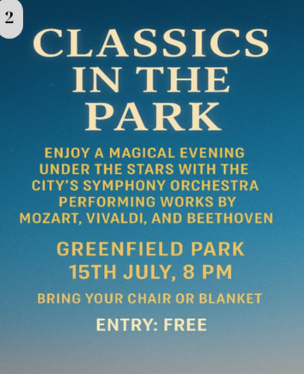
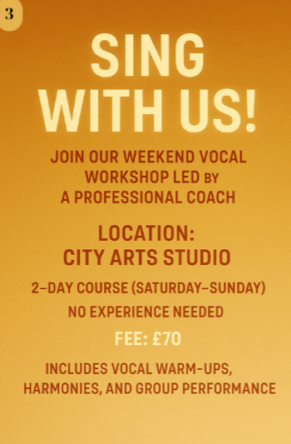 | 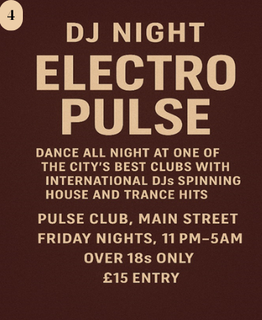
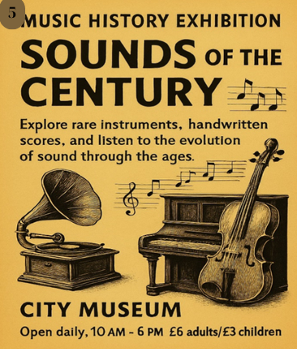 | Which advertisement is about…  A. an evening of timeless compositions  B. learning how to sing  C. listening to live rock music  D. a silent disco  E. exploring music from the past  F. a club event with electronic music  G. playing instruments in a band  H. a song writing competition

Task 2. Read the text below. Choose the correct answer for questions 6–10 (A, B, C, or D).
Music Around the World
Music encompasses various styles that reflect diverse cultural influences and historical developments. Pop music is one of the most popular genres, known for its catchy melodies and relatable lyrics. Pop songs often feature upbeat rhythms designed to appeal to a wide audience. Artists like Taylor Swift and Ed Sheeran are famous for their contributions to contemporary pop music, which continues to evolve with new trends and innovations.
Rock music, another prominent genre, emerged in the 1950s and has since diversified into various subgenres like classic, punk, and alternative rock. Characterized by electric guitars, powerful vocals, and energetic performances, rock music has a rebellious spirit that resonates with audiences seeking intensity and authenticity. Bands such as The Beatles and Nirvana have left a lasting impact on the genre, inspiring generations of musicians worldwide.
Turning to a different style, jazz is celebrated for its improvisational nature and complex rhythms. Originating in African American communities in the early 20th century, jazz blends influences from blues, ragtime, and European classical music. Jazz legends like Louis Armstrong and Miles Davis pioneered different styles in this genre, from swing to bebop, influencing music beyond the jazz scene and into mainstream culture.
Classical music, whose history dates back centuries, represents a tradition of symphonies, operas, and chamber music compositions. Composers such as Mozart, Beethoven, and Bach are famous for their mastery of structure, harmony, and emotion. Classical music is often performed by orchestras and ensembles, showcasing complicated arrangements and the skillful interplay of instruments that captivate listeners with its timeless elegance and depth.
Lastly, electronic music has changed the way we experience sound through synthesizers, drums, and digital production techniques. Artists like Daft Punk and Skrillex have pushed boundaries, reshaping popular music and inspiring new generations of electronic musicians.
Each musical style offers a unique journey through sound, reflecting the creativity and cultural expressions of its time and place. Whether it's the infectious melodies of pop, the energy of rock, the improvisational spirit of jazz, the timeless elegance of classical, or the innovative sounds of electronic music, each genre invites listeners to explore and appreciate the diversity of musical artistry across the globe.
6. What is a defining characteristic of pop music?
A) Strong improvisation and complex rhythms
B) Use of orchestras and operas
C) Snappy tunes and mainstream attraction
D) Heavy use of electric guitars and rebellious themes
7. What music genre is known for its defiant attitude and electrifying shows?
A) Classical
B) Pop
C) Jazz
D) Rock
8. What does jazz music emphasize the most?
A) Emotional storytelling through lyrics
B) Structured harmonies and rigid form
C) Spontaneous creativity with complex beats
D) Digital sounds and synthetic beats
9. Which of the following statements is TRUE about classical music?
A) It emerged in the 20th century alongside jazz
B) It is performed mostly by solo vocalists
C) It features experimental sounds and modern beats
D) It focuses on well-structured compositions and the collaboration of instruments
10. In what way does electronic music differ from the other genres discussed?
A) It uses digital technology to create sound
B) It originated before classical music
C) It focuses on live acoustic instruments
D) It avoids rhythm and melody completely

Task 3. Read the texts below. Match choices (A – H) to (11 – 16). There are two choices you do not need to use.

11. Vinyl Revival
A small, independent record store specializing in rare and vintage vinyl records. Customers often drop by to chat about classic rock and pick up limited-edition albums. The shop also hosts occasional acoustic sets from local bands.
12. The Jazz Loft
This basement venue has a laid-back vibe and hosts live jazz performances every weekend. The interior is decorated with vintage instruments and black-and-white photos of famous jazz legends. There’s no stage—musicians play right next to the audience.
13. Harmonia School of Music
Established in 1992, this school offers music lessons for all ages and skill levels. Students can choose from piano, violin, guitar, or voice, and participate in seasonal recitals, which are held in the school’s auditorium.
14. Groove City Studios
This professional recording studio has welcomed many well-known artists from around the world. Equipped with state-of-the-art technology, it also provides services for aspiring musicians looking to produce demos and albums.
15. Symphony Park
Every summer, this outdoor venue hosts a series of open-air classical concerts, which are performed by a full orchestra. Families bring picnic blankets, and food trucks line the park for snacks and drinks.
16. Beat Byte Café
A cozy coffee shop where guests can enjoy live indie performances in the evenings. The café has become a popular hangout for students and emerging artists. Free Wi-Fi and an excellent playlist keep people coming back.
Which place __________?
A. gives lessons on different instruments
B. is popular with fans of older music formats
C. has no chairs or tables inside
D. regularly features jazz performers
E. provides a place to make professional recordings
F. holds concerts under the open sky
G. is known for its free internet service
H. was founded by a famous composer

Task 4. Read the text below. Choose from (A-H) the one which best fits each space (17-22). There are two choices you do not need to use.

Attending a Concert
Going to a concert is an exciting experience (17) __________. Whether it's your favorite band or a new artist you’ve just discovered, live music creates a unique atmosphere (18) __________.
For many fans, a concert is more than just music — it’s a shared moment with others who love the same songs and sounds. Large venues often sell out quickly (19) __________. Arriving early ensures a better view and allows time to find your seat or place near the stage.
Modern concerts often feature advanced lighting and sound systems (20) __________. These effects make performances more thrilling and memorable. However, loud music can damage hearing (21) __________. Experts recommend ear protection, especially during long events or when you are near speakers. Despite some challenges, attending a concert is an unforgettable event (22) __________ for music lovers of all ages.

Options (A–H):
A. that people talk about for years
B. that bring the music to life
C. if you don’t wear the right clothes
D. which brings thousands of people together
E. and it requires planning ahead
F. that enhance the artist's performance
G. because tickets are limited
H. so it’s important to take precautions

Частина “ВИКОРИСТАННЯ МОВИ”
Use of English

Task 5. Read the text below. For questions (23 – 27), choose the correct answer (A, B, C, or D).
Being a composer is more than simply writing music. It requires a deep (23) ________ of musical theory, structure, and emotion. Great composers don’t just follow rules — they know when to (24) ________ them to create something truly original.
Inspiration can come from anywhere: nature, personal experiences, or even a single sound. But turning that inspiration into a complete piece demands discipline and (25) ________. Many composers spend hours revising and improving their work until every note feels just right.
Some composers work alone, while others (26) ________ with performers, conductors, or even filmmakers. Regardless of the process, the goal is the same: to (27) ________ music that moves and connects with people.

 | A | B | C | D
23 | understanding | definition | suggestion | instruction
24 | explain | break | avoid | test
25 | talent | pressure | patience | training
26 | compete | create | collaborate | compare
27 | describe | compose | deliver | perform

Task 6. Read the text below. For questions (28 – 32), choose the correct answer (A, B, C, D).

Adele
Adele Laurie Blue Adkins, known professionally as Adele, is one of the most successful British singers ever. Before she became famous, she (28) _______________in small clubs around London, gaining confidence and experience. She (29) ______________ her songs as a teenager, inspired by heartbreak and personal struggles.
In 2008, her debut album “19” (30) ________________ and was praised by critics for its emotional depth. After Adele won two Grammy Awards in 2009, her fame skyrocketed. She admitted that winning (31) ___________ her life overnight. For Adele, (32) ______________ was never just a job; it was her passion.

 | A | B | C | D
28 | performs | had performed | is performing | has performed
29 | was used to | used | used to | use to
30 | was released | has released | released | is released
31 | had changed | would change | will change | was changing
32 | sing | singing | to sing | she sings

Keys:
Task 1:1C 2A 3B 4F 5E
Task 2:6C 7D 8C 9D 10A
Task 3:11B 12D 13A 14E 15F 16G
Task 4:17E 18D 19G 20B 21H 22A
Task 5:23A 24B 25C 26C 27B
Task 6:28B 29C 30A 31A 32B

Пояснення до тренувального тесту № 1
Task 1:
- Live at the Arena – Arctic Lights Tour
C – listening to live rock music. The phrase “high-energy rock concert” and mention of “the famous indie band Arctic Lights” clearly indicate a live rock music performance. “Live at the Arena” also suggests a typical concert setting.
- Classics in the Park
A – a night out with classical music. This performance by “the city’s symphony orchestra” features composers like Mozart, Vivaldi, and Beethoven as part of classical music. It takes place in the evening “under the stars,” which makes it a night event.
- Sing With Us!
B – learning how to sing. The event is a “vocal workshop” with a “professional coach” and mentions things like “vocal warm-ups” and “group performance.” It's a class for people to learn singing, especially since “No experience needed” is stated.
- DJ Night: Electro Pulse
F – a club event with electronic music. It mentions “DJs spinning house and trance hits,” both electronic music types. The event is at a “club” and happens late at night, so it fits perfectly with a club event.
- Music History Exhibition – Sounds of the Century
E – exploring music from the past. This is an “exhibition” about music’s history, featuring “rare instruments, handwritten scores,” and how music has changed over time. The words “century” and “evolution of sound” show that it's about music from the past.
Task 2:
- What is a defining characteristic of pop music?
C) Snappy tunes and mainstream attraction
Pop music is known for its “catchy melodies” and appeal to a “wide audience,” which fits the idea of snappy, popular tunes.
- What music genre is known for its defiant attitude and electrifying shows?
D) Rock
Rock is described as having a “rebellious spirit” with “electric guitars” and “energetic performances.”
- What does jazz music emphasize the most?
C) Spontaneous creativity with complex beats
Jazz is “celebrated for its improvisational nature and complex rhythms,” highlighting creativity and musical complexity.
- Which of the following statements is TRUE about classical music?
D) It focuses on well-structured compositions and the collaboration of instruments.
Classical music is praised for “structure, harmony, and emotion,” performed by “orchestras and ensembles.”
- In what way does electronic music differ from the other genres discussed?
A) It uses digital technology to create sound
Electronic music uses “synthesizers, drums, and digital production techniques,” distinguishing it from acoustic-based genres.
Task 3:
- Vinyl Revival – B. is popular with fans of older music formats
This shop specializes in rare and vintage vinyl records, which appeals to people who love old-school music formats like vinyl.
- The Jazz Loft – D. regularly features jazz performers
It hosts live jazz performances every weekend and is decorated with jazz-themed memorabilia, making it focused on jazz.
- Harmonia School of Music – A. gives lessons in different instruments
It offers piano, violin, guitar, and voice to all ages, which fits the idea of teaching multiple instruments.
- Groove City Studios – E. provides a place to make professional recordings
This is a recording studio used by well-known artists, offering services to musicians looking to produce music professionally.
- Symphony Park – F. holds concerts under the open sky
It describes open-air classical concerts in a park during the summer, which fits the idea of outdoor musical events.
- Beat Byte Café – G. is known for its free internet service
It mentions free Wi-Fi and a welcoming vibe for students and indie music fans, making it a spot known for internet access and music.
Task 4:
- E – "and it requires planning"
“Going to a concert is an exciting experience…”
This is a general statement. The phrase “and it requires planning ahead” adds a natural follow-up, suggesting preparation is needed (e.g., buying tickets, getting there early).
- D – "which brings thousands of people together"
“…creates a unique atmosphere…”
This explains what makes that atmosphere unique — the shared experience with many fans.
- G – "because tickets are limited"
“Large venues often sell out quickly…”
This is a cause-and-effect relationship. Why do they sell out? Because ticket numbers are limited.
- B – "that brings the music to life"
“Advanced lighting and sound systems…”
This describes the purpose or impact of these systems — to enhance the experience.
- H – "so it’s important to take precautions."
“However, loud music can damage hearing…”
This sets up a warning. “So it’s important to take precautions,” logically follows — it's a result or advice due to the potential risk.
- A – "that people talk about for years"
“…an unforgettable event…”
This phrase reinforces how memorable concerts can be.
Task 5:
- A– Understanding of musical theory
The correct answer is understanding because composers need to have a deep comprehension of music theory, structure, and emotion in order to craft original and meaningful compositions. The word "understanding" fits as it conveys the necessity of intellectual engagement with music theory.
- Definition is too narrow and doesn't capture the depth of knowledge required.
- Suggestion would imply a less certain approach, which isn't suitable here.
- Instruction suggests a more formal or educational aspect, which is not what the passage focuses on.
- B – Breaking the rules of music
The correct answer is break because composers are described as knowing when to break the rules to create something original. This matches the context of the passage, where it talks about the need to break free from conventions.
- Explain implies giving a detailed account, which isn't relevant to the context of breaking rules to create something new.
- Avoid suggests steering clear of something, which contradicts the idea of intentionally breaking rules.
- Test doesn't fit the idea of creation or breaking rules, as it implies a trial or experiment rather than an active decision in music composition.
- C– Patience in the composition process
The correct answer is patience because the passage emphasizes that composers often spend hours revising their work, suggesting that patience is crucial for perfecting their compositions.
- Talent implies an innate ability, but the passage stresses the process of revision and improvement, which is more about persistence and patience than innate skill.
- Pressure would suggest that composers are under stress, which isn't mentioned as a key factor in their process.
- Training refers to formal instruction, but the passage talks more about discipline and revising, not just formal learning.
- C – Collaboration with other musicians
The correct answer is collaborate because the passage mentions composers working together with performers, conductors, or filmmakers, which suggests cooperation and teamwork.
- Compete suggests rivalry, which doesn't align with the passage's message about composers working together.
- Create is too general and doesn’t emphasize the partnership aspect.
- Compare doesn’t fit because the passage is about working together, not comparing ideas.
- B– Compose music that moves people
The correct answer is compose because the passage talks about composers’ goal of creating music that emotionally connects with people. Compose directly refers to the act of creating music, which is the main focus.
- Describe refers to explaining something in words, which doesn’t fit the context of creating music.
- Deliver implies presenting or distributing, not the creative process itself.
- Perform involves playing or singing music, not composing it, which is the task described in the passage.

Task 6.
- – B – had performed
The correct answer is had performed because it refers to an action that happened before another event in the past — in this case, before she became famous. This is the Past Perfect Tense, used to describe an action completed before another past action.
- – C – used to
The correct answer is used to because it refers to a past habit or repeated action that no longer happens — in this case, writing songs as a teenager.
- – A – was released
The correct answer is was released because this is a passive construction in the Past Simple, used when the subject (the album) is not performing the action but receiving it.
- – A – had changed
The correct answer is had changed because this again shows Past Perfect, indicating that the change in her life happened before the moment she was talking about it.
- – B – singing_
The correct answer is singing because after prepositions like “For”, a gerund (verb+ing) is required. Singing works here as a noun describing the activity she loves.

